JAVA 3 Activity 3 Task 1

30003389 – Kyer Potts

Table of Contents

Table of Contents i

What is the difference between a set and a list? 1

You decide you want to roll 2 dice and see what the frequency is of each possible number combination. Would you use a Set collection to do this? State your reason(s). 1

Would the following Collection.Sort() statements both work? Explain your answer. 1

Stack Implementation 2

# What is the difference between a set and a list?

A list is an ordered sequence of elements, it can be traversed in both directions with the appropriate method and can contain multiple duplicate elements. Sets cannot contain duplicate elements and are unordered. Because of this, all elements implemented in a set must be unique. Sets also can only be traversed in one direction.

# You decide you want to roll 2 dice and see what the frequency is of each possible number combination. Would you use a Set collection to do this? State your reason(s).

In order to get an accurate, read out of the frequency that each number will show up on each dice, many iterations of the roll will need to be performed which will yield many duplicate results. Because of this, a Set would not be an appropriate data structure, it cannot contain duplicate elements, which means that results stored within the set will be invalid and representative of the actual frequency of dice rolls.

# Countries Collection HashSet

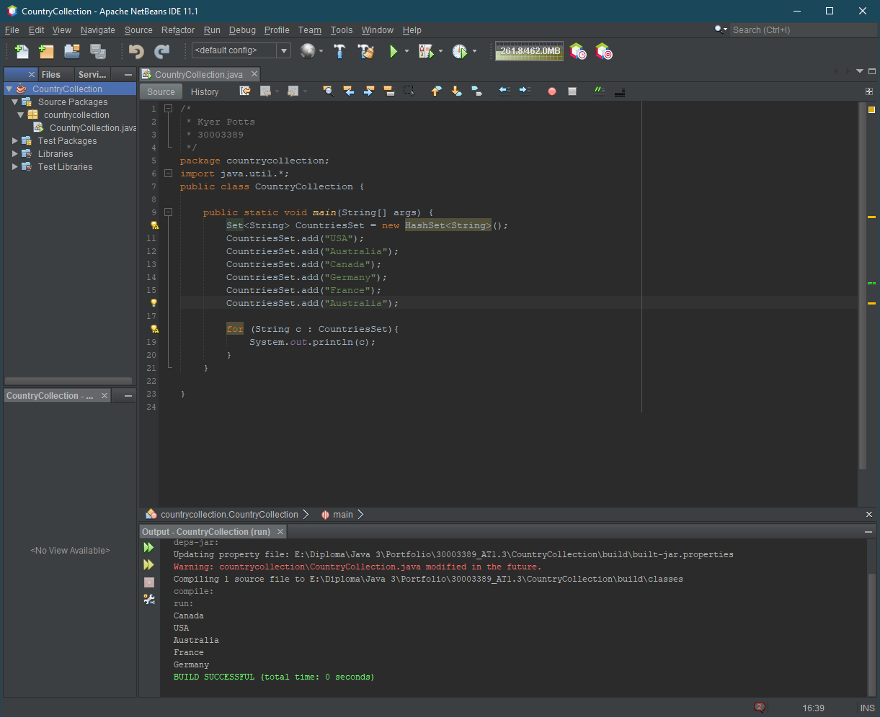

# Would the following Collection.Sort() statements both work? Explain your answer.

HashSets cannot be sorted without converting the data structure into a List or a TreeSet. This is an indirect method of sorting HashSets and can be used as a workaround if required. HashSets cannot be implicitly so the the Collection.Sort() method will only work on the List in the code provided.

# Stack Implementation

